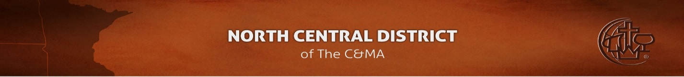
BIBLE QUIZZING NORTH CENTRAL (BQNC)
Money submission form
Please print this form and include the following information with your check made out to ‘NCDCMA Quizzing’. Thanks!

Name of church or group:

Contact name:

Contact phone or email:

Money for (please put an ‘X’ preceding the fund)
Yearly registration
Crown Tournament registration
Books
Gift
Equipment
Internationals
Scholarship
Other (please specify)

Receipt requested
Yes
No

Signature: Date sent: / /

Checks should be sent to:
North Central District CMA
Attn: Doug Parkinson
8860 College View Drive
Saint Bonifacius, MN 55375

Official use only
Date Received: / / Date processed: / /

Initials:

Information forwarded to: Date: / /

O:\Forms\BQNC district monies form Revised 06/11/2014

