These screen shots are from a test run of the registration system so are hopefully quite close to what you will see as you register for the Bible Quiz regular season.
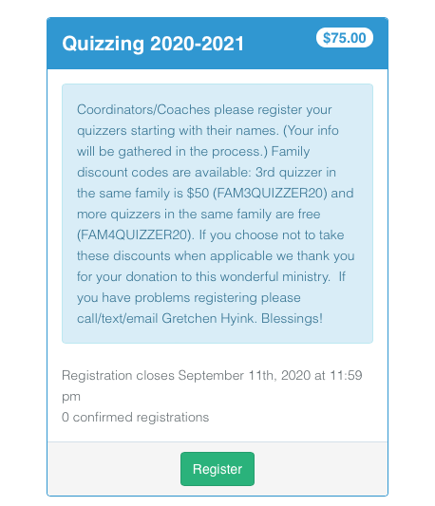

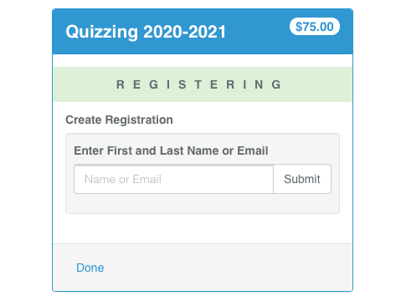 Enter the quizzer's name, click submit and choose a matching profile or create a new profile if no matching profile appears.

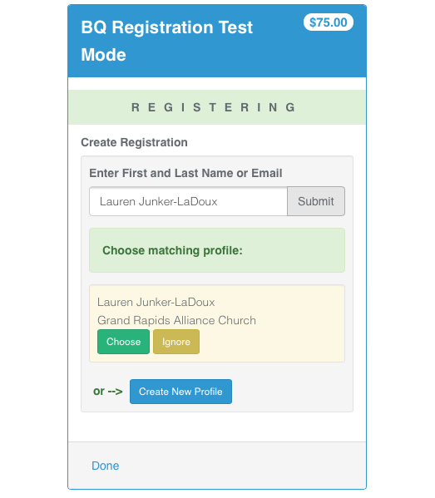 If more than one matching profile appears you may select either one. (Duplicates will eventually be deleted from the data base.) Whenever the team name is changed information about the coordinator, coach, division and zone will need to be entered. After all the information is entered click save. Then click add registration and repeat the process. When all your quizzers are entered, click pay.

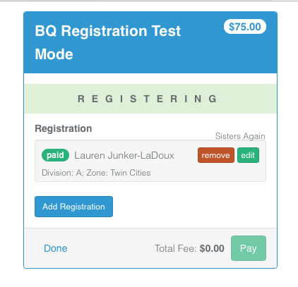This is an example of how it would look if the 4th family quizzer discount was taken - marked as paid.
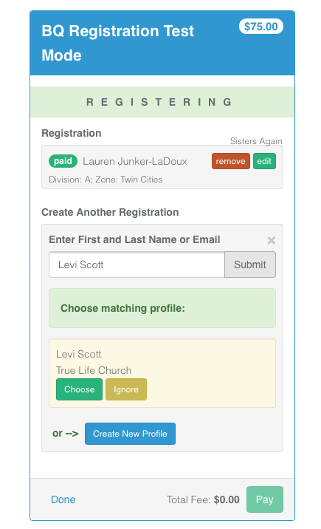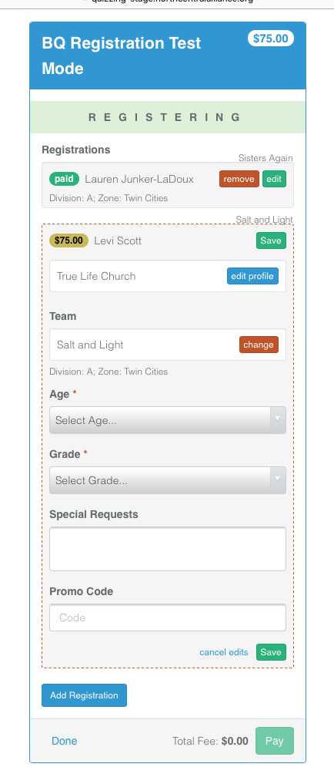 This is where discount codes are entered if applicable and desired. Siblings DO NOT need to be on the same team to be eligible for the family discount.
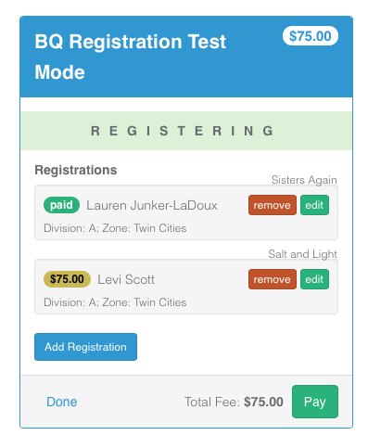
This is only a team of two in this case. We believe you will be able to register unlimited teams and quizzers in one registration process.
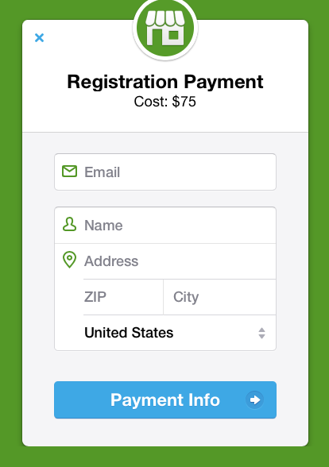
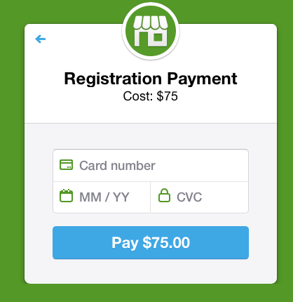
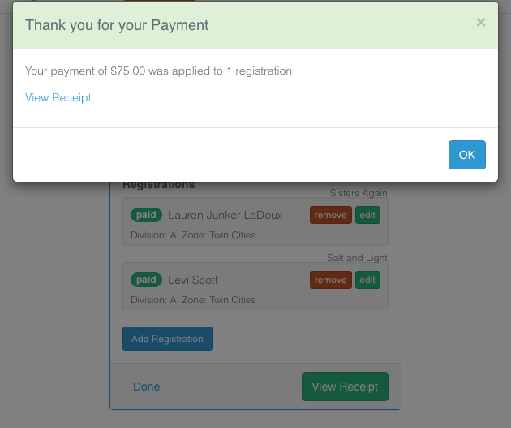
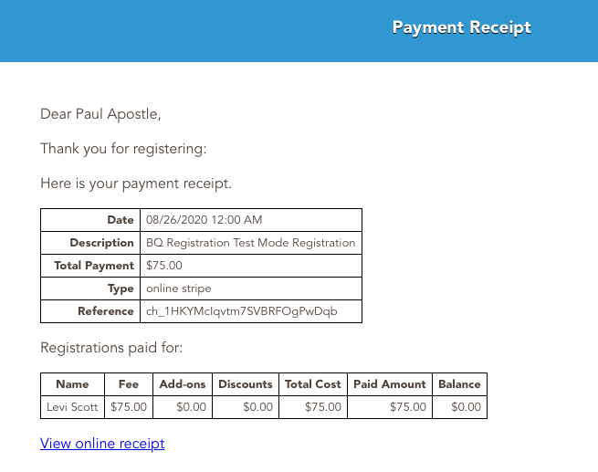The fourth quizzer from the same family does not appear in the Payment Receipt because she received the full discount for being the 4th family member quizzer and therefore did not need to pay. However, they are registered.
