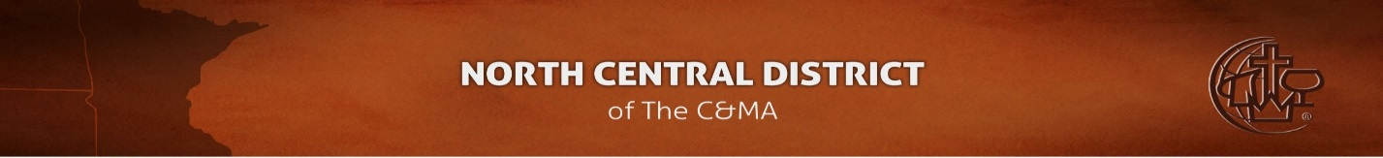
BIBLE QUIZZING NORTH CENTRAL (BQNC)
Money submission form
Please print and include the following information with any cash, check or EFT you submit to ‘BQNC’. Thanks!

Name of church or group:

Contact name: _

Contact phone or email:

Money for
- Yearly registration
- Crown Tournament registration
- Books
- Gift
- Equipment
- Internationals
- Scholarship
- Other (please specify)

Receipt requested
- Yes
- No

Signature: _ Date sent: / _/

All monies sent to:

Dianne Enns
8700 College View Drive
Saint Bonifacius, MN 55375

Official use only
Date Received: / / Date processed: / /

Initials:

Information forwarded to: Date: / /

O:\Forms\BQNC district monies form Revised 07/14/12

